1. What is the use of the git add command?

* The git add command stages changes in your working directory for the next commit.
* It tells Git which files you want to include in a snapshot.

1. Write the command to create a branch “feature-group”.

* To **only create** (without switching) - git branch feature-group
* To create **and switch** to a branch - git checkout -b feature-group

1. What is a pull request? Write the steps involved in creating a pull request.

* Push your branch to the remote repository.
* Go to GitHub and click **"Compare & pull request"**
* Click **"Create pull request"**.

1. How do you add collaborators?

* Go to your repository → **Settings** → **Collaborators**
* Click **“Add collaborator”**, enter their username, and send the invite.

1. What is the command used to commit our changes in github repo?

* git commit -m "Message"

1. Create a github account and repository to save all your assignment tasks. Example repository name: rg-assignments

* Go to <https://github.com> and sign up for a GitHub account.
* After logging in, click "New repository", name it RG-assignment, and click "Create repository".

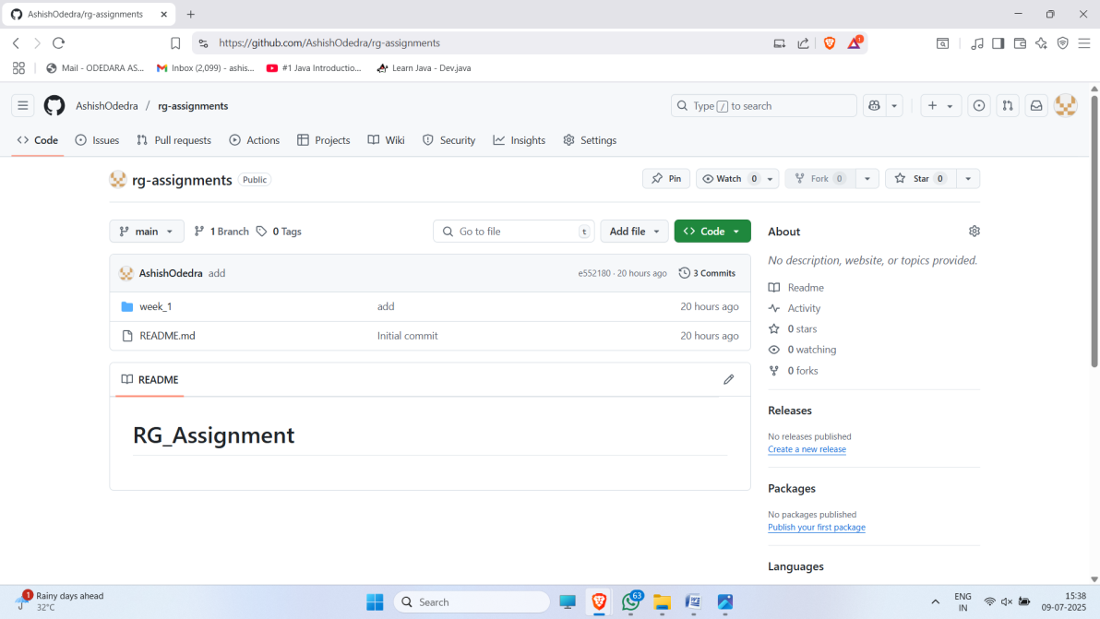

Repository Link : <https://github.com/AshishOdedra/rg-assignments>

1. Create a branch called feature-java(you can use it later to push all your java related tasks to this branch)

* git branch feature-java

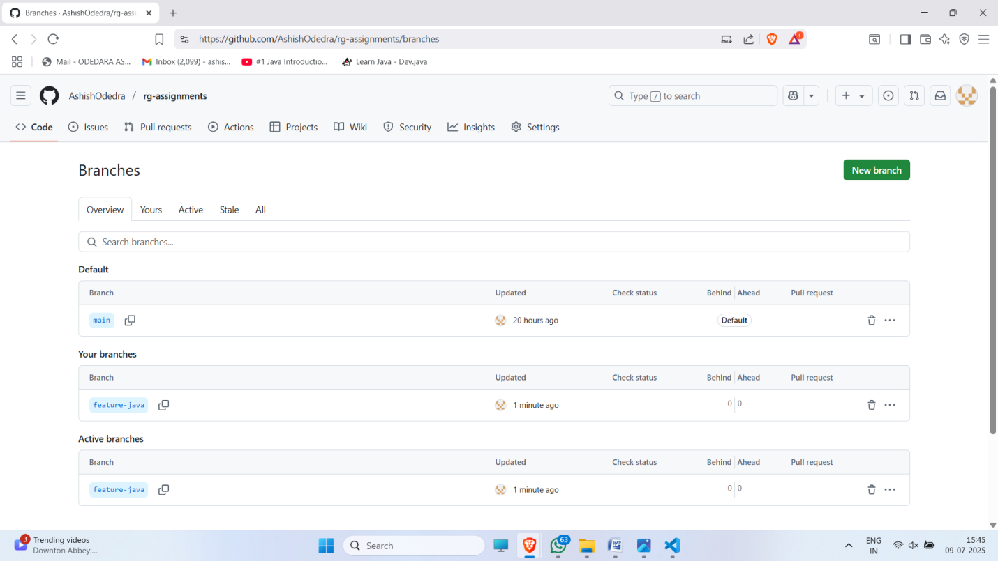

1. Install IntelliJ IDE. Create a simple java project displaying “Hello World!!”and share the screenshot.

* Download and install IntelliJ IDEA from <https://www.jetbrains.com/idea/>.

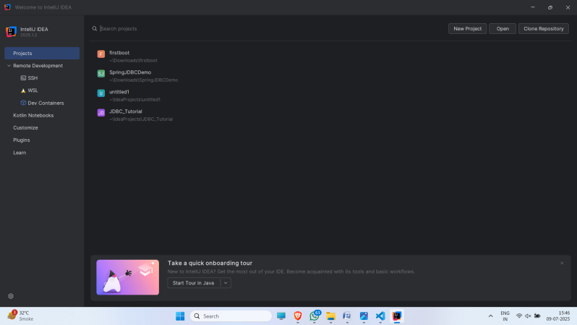

* Open IntelliJ → New Project → Select Java → Create a class with main method and print “Hello World!!”.

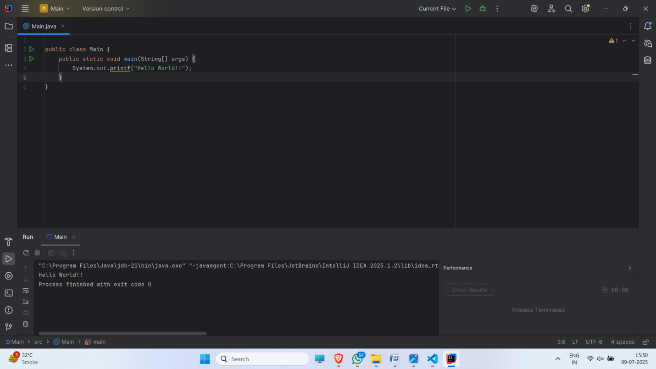

1. In IntelliJ IDE, explore the shortcut keys for the following
2. To run the project - Shift + F10
3. To select a line - Ctrl + W
4. To comment/uncomment a line - Ctrl + /
5. To delete a line - Ctrl + Y